Appendix 10: New Features in v3.5 C
Port Flow Analyzer has had many updates since this user manual was written for the original v3.0 for Windows. These include
3.0 A through v3.0 E, v3.5 A, v3.5 B and now v3.5 C. For the features added to the v3.5 B since Appendix 9 was written, refer to the Readme.doc file (click on Help, then Display Readme.doc File) in the program. Listed here are features introduced in v3.5 C:
- Basic Version
- Professional (Pro) Version (includes all Basic features and more advanced Pro features)
- Head Porter Version (includes all Basic and Professional features and more advanced Head Porter features) Here is a listing of the major enhancements and new features for v3.5 C.

Data Recording:
There is now an option under Velocity in the Recording screen for producing different pitch sounds for the port velocity. This way you can listen to the port velocity change as you move your pitot tube or Electronic Velocity Probe in the port. Now you can concentrate on exactly where the probe is and hear if that area has high or low velocity. Head Porter Version only. Fig A56.

The program now has several new features for reading swirl and tumble. Fig A56.
- The program now saves individual USB Swirl Readings and checks them to see if there are any outliers (outside 25% of the average). If there are any of these readings, they are omitted and a new average and spread (+/- %) is calculated.
- You can now pick from 3 different analog swirl meter inputs for the new USB Black Box.
- The program now disables menu item Micro USB Swirl Version if you have not checked Micro USB Swirl as the type of Swirl Meter.
- The program is now more reliable at realizing Swirl readings were not being recorded, and eliminated checking swirl settings "behind the scenes".
- Now there is an option under Swirl/Tumble in Calibrations screen of None to turn off Swirl and Tumble features.
- Program now checks to see if USB Swirl Meter and Logger (SF Flowcom, Black Box, etc) are using same Com Port and warns you of conflict.
- If you are not recording either Swirl or Tumble, the “Rezero Swirl/Tumble” option in the Recording screen is not shown. Fig A59.

The program now displays message only once for each program startup that the units are not matching between the Flowcom and the program’s settings.

Program now records only 1 reading for Port Velocity reading if you are using a FlowCom and was having the FlowCom doing "slower, more reliable" communications via a Preference Setting. This speeds up testing when recording slowly.

The program now better averages data readings you are using a FlowCom and was having the FlowCom doing "slower, more reliable" communications via a Preference Setting to speed up testing.

Program now fixes corrupt FlowCom strings when checking for flow bench type.

Added option in FlowCom or Electronics screen to allow displaying of the Actual CFM (not corrected for test pressure). If you request 'Show Actual CFM', the Corrected CFM is displayed in a slightly smaller font, and the Actual CFM (not corrected for test pressure) is displayed in an even smaller font below it. Pro and Head Porter version only. Fig A63.

The program now has a lower limit for displaying live CFM reading for some types of loggers. Note that the correct data was recorded and displayed if you recorded the data point, it was just not displayed in the FlowCom or Electronics screen.
The program now more reliably lets you know the pressure sensors are maxed out (producing incorrect data) for the new Black Box Mini USB. Fig A58.

Data Analysis (including Graphs and Reports):
Program now has a Printed Data option for printing the actual Port Velocity numbers on the Port Velocity Maps. Click on File, then "Edit Printed Comments and Data Output" and check "Include Port Vel. Map Numbers". Head Porter Version only. Fig A62.

Fixed bug where the averages for the Exhaust data in reports could be done incorrectly. Intake data was always OK.

The limits for the bar gauges in the Recording Screen for the Head Porter version are now set in Preferences, under the “Printing/Graphing” tab. Before this they were set in the Recording Screen, but this was unreliable because of communications taking place with a data logger. Fig A59.

You can now include a graph or “live data” on the Recording Screen to track trends in several variables during testing. Head Porter Version only. Fig A63.

There is now a Preference setting to let you keep the Graph on the main screen always at the same graph scales. This can cause problems if you open files with different lifts and flows than you normally run, or the heads you flow produce quite different flows. However, if your tests are always at about the same lift and flow, this new Preference makes it easier to spot changes with the graph on the main screen. Pro and Head Porter Version only. Fig A64.

Hardware:
For our EZ Flow systems, there is a new feature letting you add a special “Low Flow” sensor. This lets you measure very low flows to check for leakage or for measuring flows on very small components or at very low valve lifts. Head Porter Version only. Fig A65, A66.

Added option in FlowCom screen to set the Delay Time for turning the SF1020 motor on/off if doing flow range change or flow direction change. Fig A59.

FlowCom screen lets you change the flow direction for the SF1020 bench. Fig A59.

If you use a recording switch in a temperature channel AND use the same channel for recording temperature, the "temperature" which is considered pressing the Record Switch has been lowered from about 158 deg F down to about 150 deg F. This better ensure the system will see the recording switch, but can create problems if you are trying to record temperatures which are close to 150 deg F (extremely unusual condition).

Emailing and File Handling:
Under 'File', then 'Save As' there are new options to see other files in each folder, then choose a name from the folder to make it easy to modify a new name based on a previously used name. There is also a new "Add New" button to easily add a new folder name. Fig A67.

Under 'File', then 'Save As' there is a new “Edit Many Tests” button. This allows you to identify many tests, by using the Ctrl key when clicking on a test, or clicking on a test, then hold the shift key to click on another test and identify all the tests in between. Then you can choose to Delete these tests (actually send to recycle bin), or copy or move these tests to a different folder. If you choose ‘Move’ they are removed from the current folder. Pro and Header Porter versions only. Fig A69.
There is a new Open option of "List by Access Date". With this activated, the most recent test files you have worked with show up at the top of the list. Pro and Header Porter versions only. Fig A73.

Many screens now allow for much longer folder and file names. These include the “Open a File”, “Save As”, “Starting a New Test”, Filtered Files displayed in Notepad, etc.

Now using the Filter Files option, you can select which folders to check when you click "Print list of all files fitting these conditions". Pro and Header Porter versions only.

Replaced "Copy" with "Copy (or Merge)" to list of Folder Options possible in 'Save As' screen.

Program can now better display PDFs like the users manual in some versions of Windows 10. Related to this, there is a new button in Preferences for "Look for New Adobe Acrobat Reader". This way you can manually browse your computer to find the program you want to use for displaying PDFs. Fig A64.

Made several refinements to printouts and displaying screens, especially if you were including a company logo or a Test Piece picture.

There is a new Edit option of Combine Tests. It lets you combine 2 or more tests into 1. Header Porter versions only. Fig A60, A61.

Files and folders you delete now are actually sent to the Recycle Bin so they can be recovered later if you want. Fig A68.

The program is better at adding numbers to the end of file names by default. Now it will add 3 digits, like “testname001” so that you can record up to 1000 files with the base name “testname”. Prior to this it would just default to “testname1”.

Now when you open a file which has a Graph Name specified in the History Log, that Graph Name stays with the file. Previously it was restored to the default as being the File Name.

The program now has several enhancements for automatically emailing files, reports and graphs. Many of these are required to work with newer OSs, like Win 7 and Win 10. Pro and Header Porter versions only. Fig A71, A72. These include

- Program now has an 'Email Report' option in the Report screen under 'File' to explain how to email a report. There is also a new 'Emailing' option at the top of the Reports screen explaining different emailing options for reports.

- Under 'File' on the Reports screen, there is now a check box for emailing the ASCII file to an email address after it has been written.

- There is a new option in Preferences to manually locate "Location of PDF Printer Output File". This is needed in newer OSs where the PDF printer can be unpredictable.

- Now if you cancel the process of printing a PDF file for a report and emailing it, the process stops and does not proceed through to the Emailing screen.

After making a report, the File option for creating an ASCII text file has a new option. It is for making a .csv file which is compatible with Microsoft Excel. Pro and Header Porter versions only. Fig A72.

Other:
The Main Screen graph now has a title and a description of test pressure. Fig A61.

The program now better handles the Preference Setting "Early (pre 1998) FlowCom?" when it is set to "No". There is now a button in Preferences to explain how the weather corrections are used and when they are needed.
Program now explains why changes in 'Starting a New Test' screen are not saved if you don't start a new test.

If you change the printer within the program to something other than the computer's default printer, the program now restores the default printer (and printer orientation) when it shuts down.

The program is now be more reliable at opening pages on the internet for a wider range in internet browsers.

The main screen is refreshed any time you resize it. This way all parts of the main screen displayed when you make a change. Prior to this, you may not see all parts of the main screen until you went into a different screen and then returned to the main screen.

Program now displays a Progress Bar when looking for Com Ports so you know something is happening when it is checking. The program is now also less likely to say Com 3 is a correct Com Port, when it actually is not the correct port.

Program as an improved method for "Force These Lifts" button in Test Options screen, where extra rows are not blanked out and program checks if you want increments of Lift or L/D (previously was just Lift).
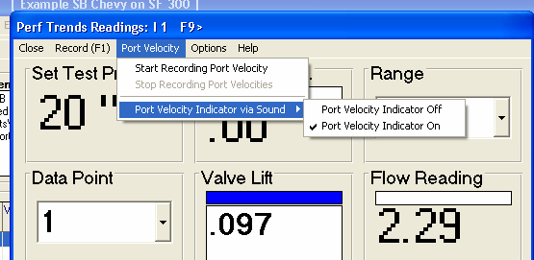
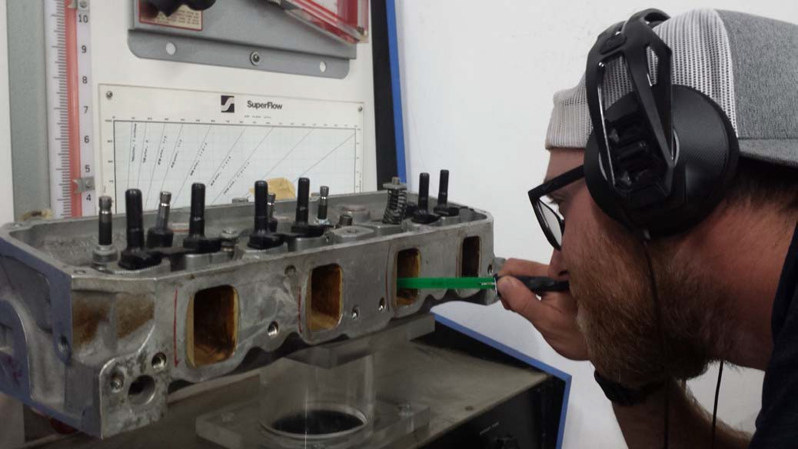
Figure A56 Sound to Indicate Port Velocity

Choose this option to turn on Sound and install a head set or ear buds on your computer to listen to a tone. The higher the pitch of the tone, the higher the velocity.

Visit our website page www.performancetrends.com. Then click on Support at the top, then Movie Demo Files for our movies page to watch and hear how this feature works. There is also a link on that page to visit our youtube page, where the movies may play better for a wider range of computers.

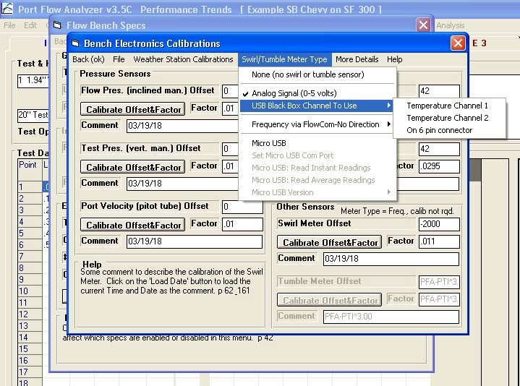
Figure A57 New Swirl Meter Options

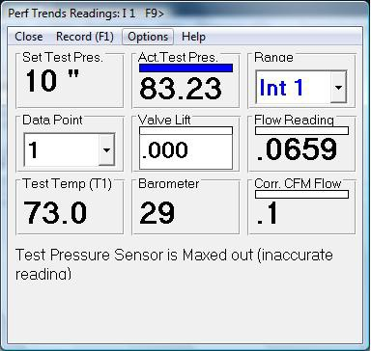
Figure A58 New Features on the Electronics Screen
If a pressure sensor is getting maxed out either at too high or too low a pressure, a warning is given that the data is not correct. This is the same as “pegging” and oil pressure gauge at, say, 100 psi when the actual pressure is 105 psi.

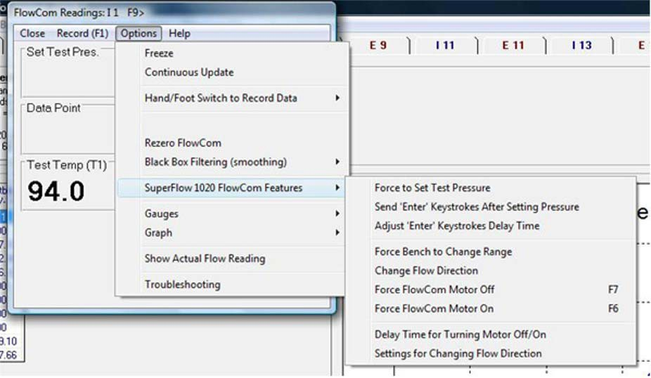
Figure A59 New FlowCom Options for SF1020 and No “Rezero Tumble/Swirl”
SF1020 FlowCom Options
No “Rezero Swirl/Tumble” if Swirl or Tumble are not being recorded.

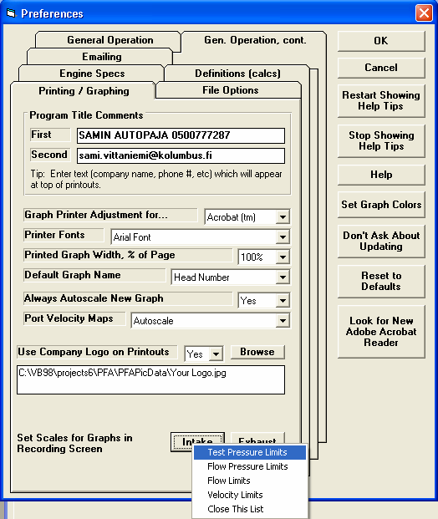
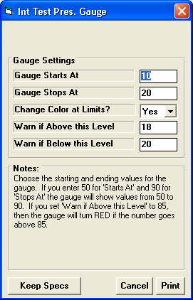
Figure A59 A New Preference Setting for Graph Scales on Recording Screen
Click on either Intake or Exhaust button and then the data type for which you want to set the graph limits.
Here you can set the limits and whether to change the graph color at certain limits.
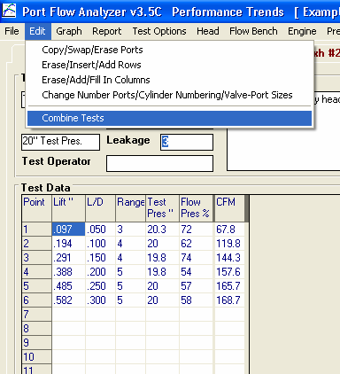
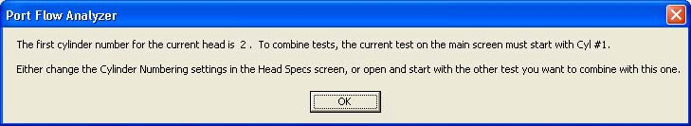
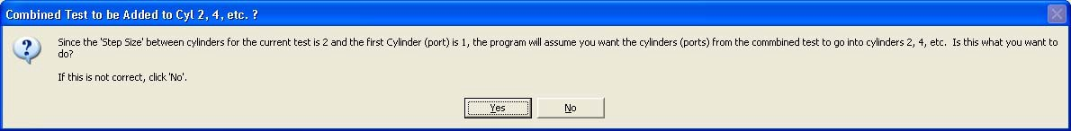
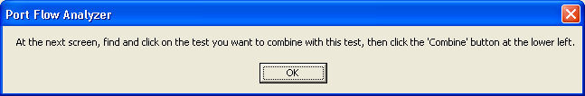

Figure A60 New Edit Feature to Combine 2 Tests into 1 Test File
If you have Head Porter version, this Edit option will appear here. It will walk you through a process as outlined by the messages below.

NOTE: You want to start this process with the file which starts with Cylinder #1. For example, a file which contains cylinders 1,3,5,7 or 1,2,3,4 are typical for V8 heads.
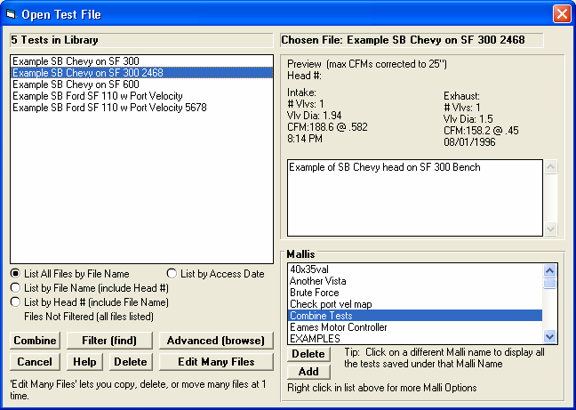
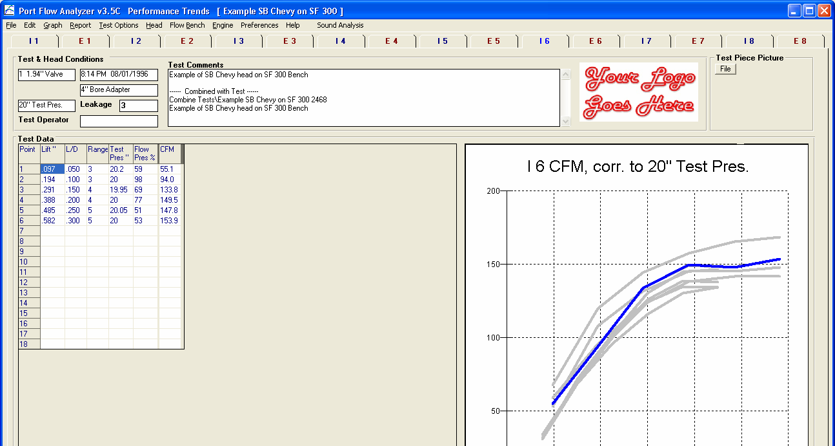
Find the test file you want to combine with the current test you started the “Combine” process with.
Then click the “Combine” button to complete the process.
Figure A61 New Edit Feature to Combine 2 Tests into 1 Test File, cont

After the Combine edit of combining the original test with cylinders 1,3,5,7 with a test with cylinders 2,4,6,8 you now have a test file with cylinders 1 through 8.
Graph now shows the port identification and the pressure the data is corrected to.
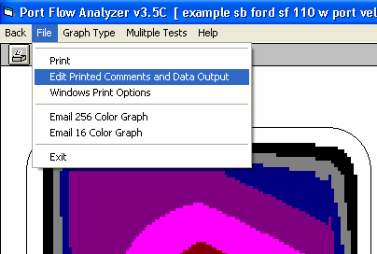
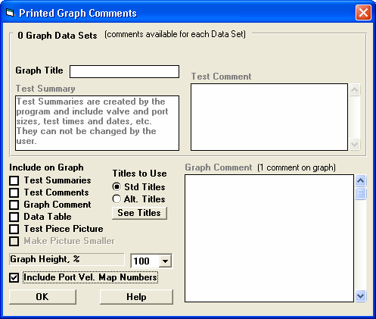
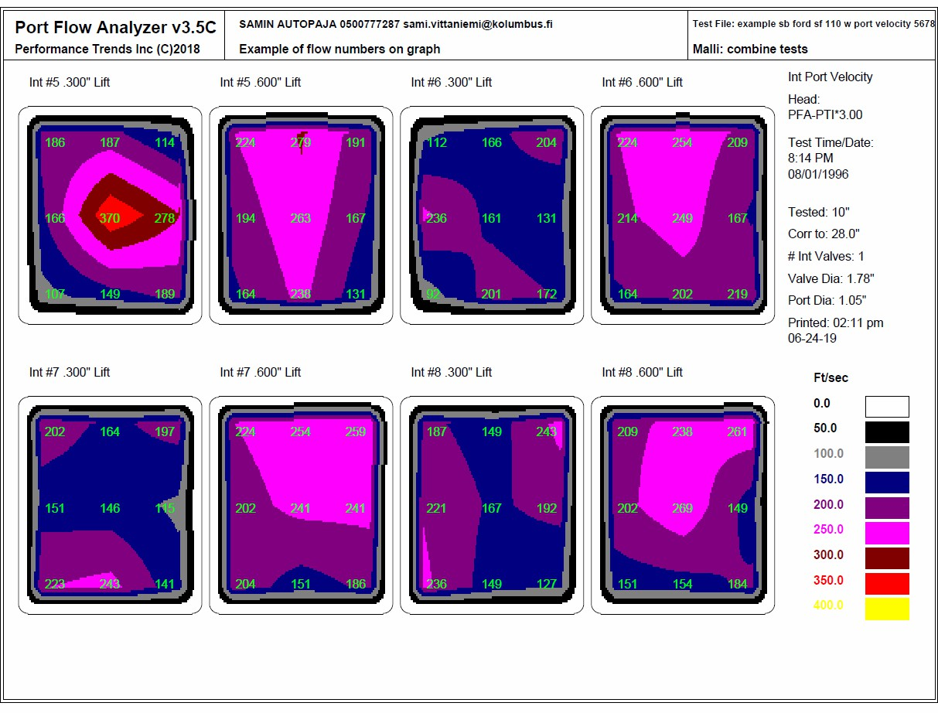
Figure A62 Including Port Velocity Numbers on Printed Port Velocity Maps

Click here under File in the Port Velocity Map Graph screen.

If you have Head Porter version you can check this option box.

Printouts will now include the exact Port Velocity number at each position you recorded.
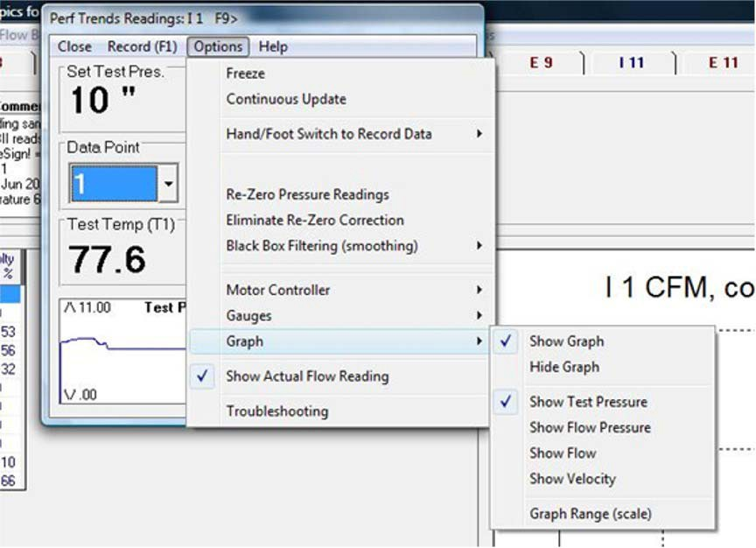
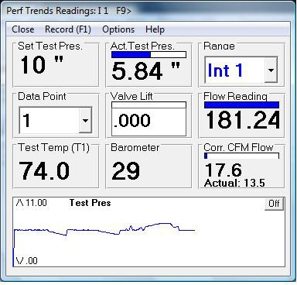
Figure A63 Include Graph on Recording Screen and Display Actual CFM

You can choose this option if you want to display the Actual CFM being measured. This CFM is NOT corrected to the desired Test Pressure and can be handy for different troubleshooting situations.
Choose to Show or Hide the Graph

Choose what you want to graph.

The limits you set for the particular data you want on the graph are the same as the bar graph for that data. These limits are now set in Preferences. See Figure A59.
Actual CFM is being shown here in a smaller font, below the Corrected CFM. Note that the Corrected CFM is higher because the Actual Test Pressure of 5.84 is less than the desired Test Pressure of 10. The program is correcting the Actual CFM up to what it should be if the Test Pressure was actually 10.
You can also click here to turn off the graph.
Graph being drawn as you watch readings in the Recording screen.

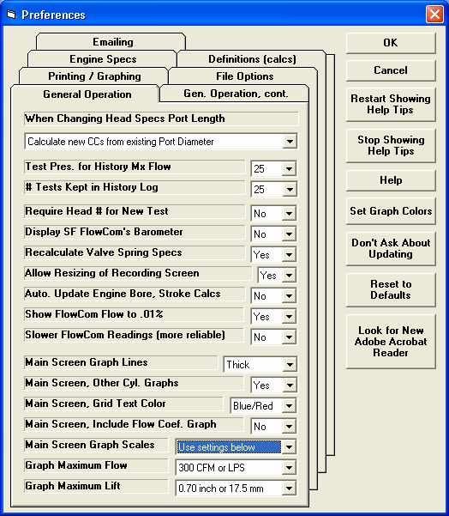
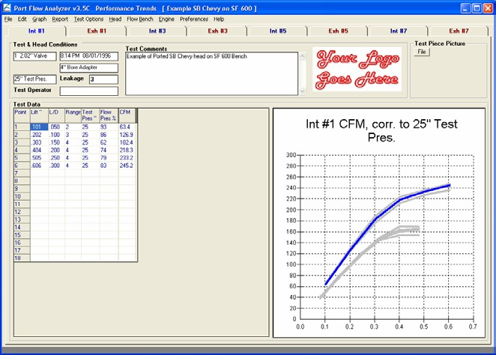
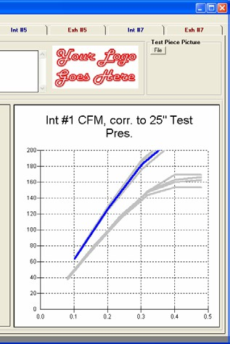
Figure A64 New Preference Settings

Several other settings for the graph on the main screen were moved down on this tab (page) to be grouped together.

This button lets you browse your computer to find Acrobat Reader for displaying PDF files, like the User Manual.

Three new Preference settings for the graph scales on the main screen. Choose Auto-Scaling to have the graphs automatically scaled to match the data for a particular test. This was the method done before this Preference was added.

With the settings shown in Preferences screen above, the graph for this particular head is shown with good detail. If the next head you flow has significantly higher flow, it will be easier to spot because the graph scales stay the same.
Scales were set for 200 CFM and .500” lift, which are too small for this data. If your results change a lot, select “Auto-Scaling” to avoid this problem
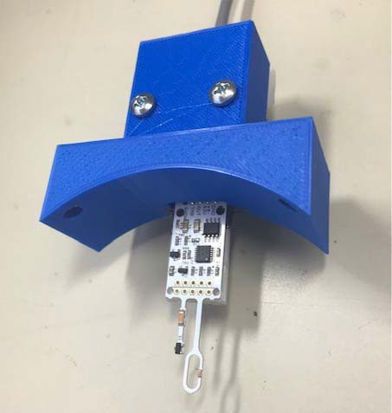
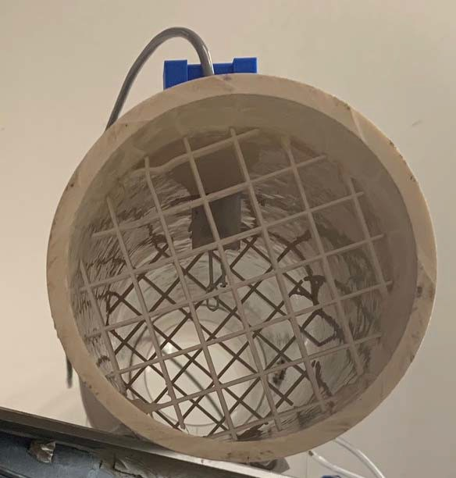
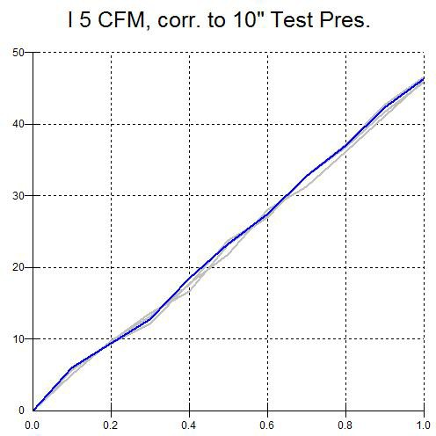
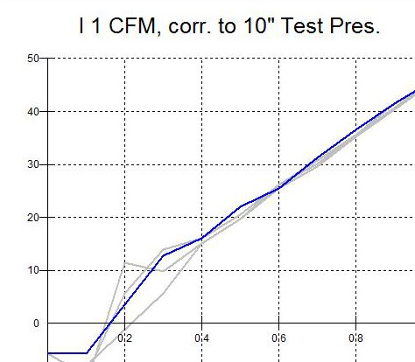

Figure A65 EZ Flow with Low Flow Sensor
Low Flow sensor for 4” EZ Flow.
Low Flow sensor installed with flow straighteners both before and after it for optimum accuracy.

Each graph below is for 4 repeat tests where the CFM was changed from 0 CFM at the 0 lift point linearly up to 45 CFM at the 1.0 lift point on an SF300 flow bench on range 2. This 4” EZ Flow system has a max flow capability of 400 CFM. With perfect results, we would see a perfectly straight line from 0 to 45 CFM.

With the Low Flow Sensor option, the flow results are accurate all the way down to 0 CFM flow.
With the standard EZ Flow system without the Low Flow Sensor option, the results are quite scattered below about 15 CFM. Many times you want to measure low flow to check for leakage or to measure flow at low valve lifts.
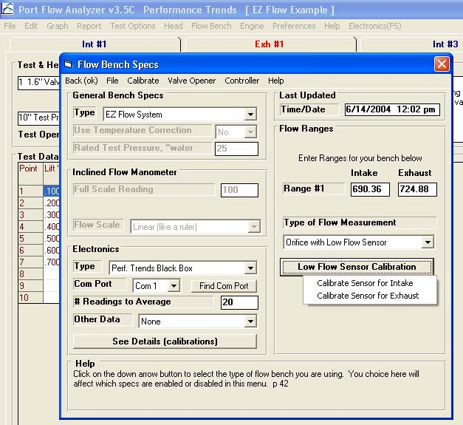
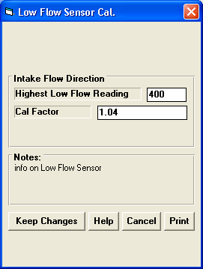
Figure A66 EZ Flow with Low Flow Sensor, cont

New option with Head Porter version is for the EZ Flow to be with just “Orifice” or “Orifice with Low Flow Sensor”. Choose the latter and the “Low Flow Sensor Calibration” button becomes enabled. If you click this button, you are presented with 2 options for entering calibration data for either the Intake or Exhaust flow direction. Then you can enter calibration data for your sensor.
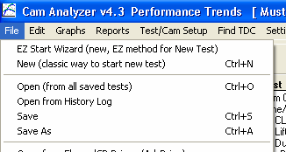
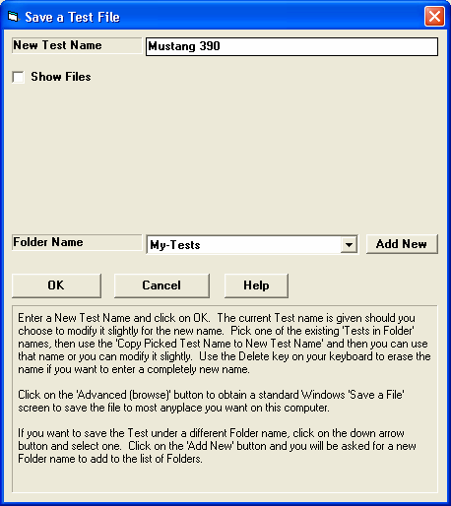
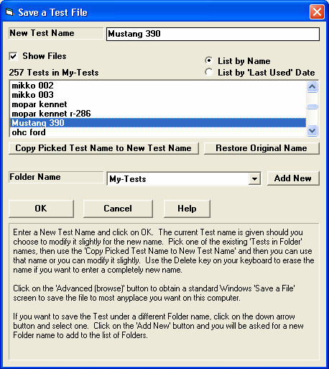
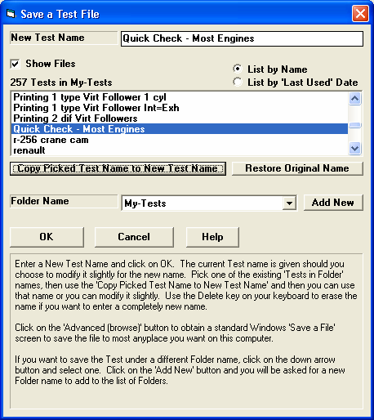
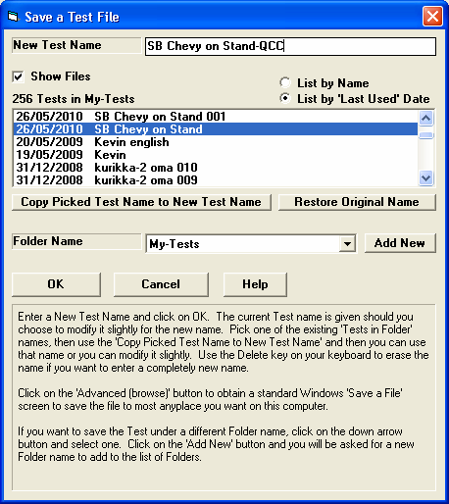

Figure A67 New “Save As” Features
Click on File, then Save As

Click this Check Box for new info and options. Many times you may want to see what other files are in this same folder, or use one of these file names as the New Test Name, or possibly modify that name slightly.

Here we are listing Test Files alphabetically by name.

Choose a Test name from the list, then click here to copy that name to the New Test Name field.
Using the Picked name and then modifying it slightly.
Listing by Date

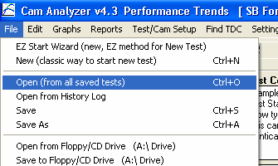
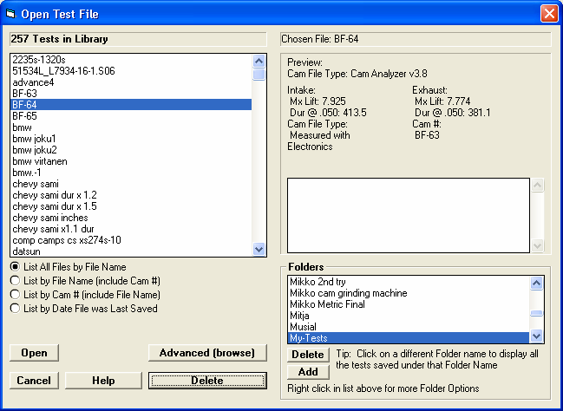
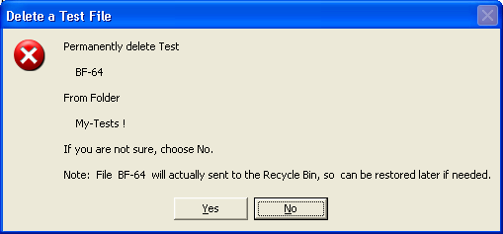
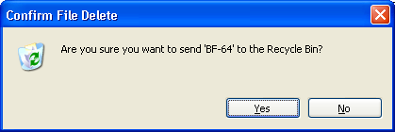
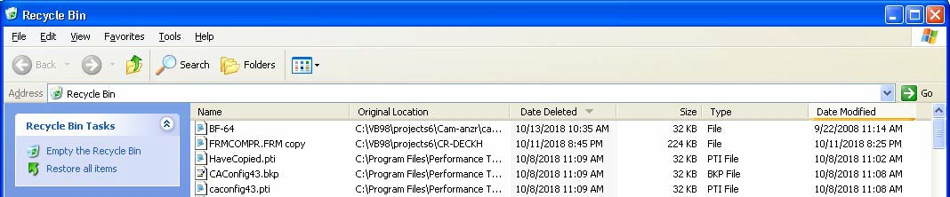
Figure A68 Saving Deleted Files and Folders to Recycle Bin

Click here for the Open screen shown to the right.
Pick a Test File, then click Delete button.
Deleted Folders are also sent to the Recycle Bin.

Deleted test file now shows up in the Recycle Bin, so you can restore it later if you have made a mistake deleting it.
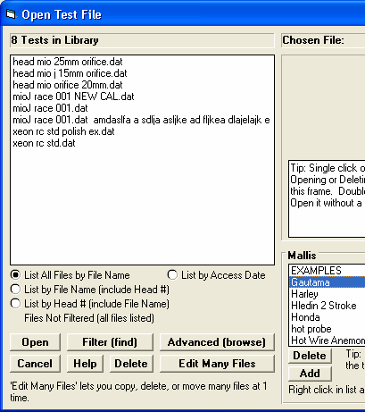
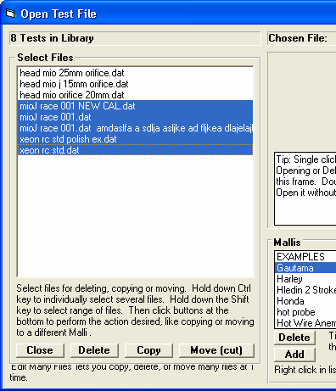
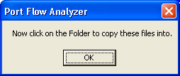
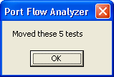
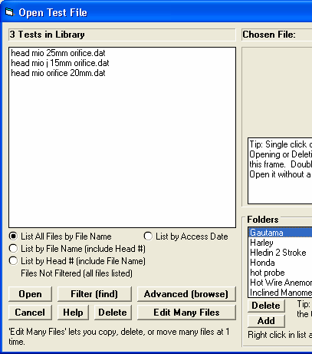
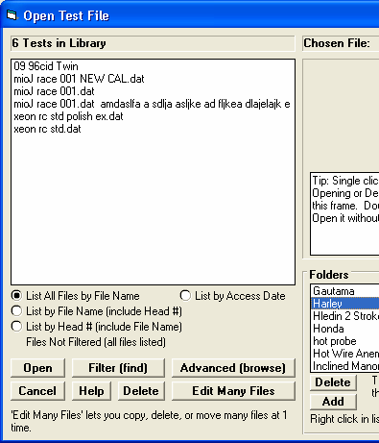

Figure A69 New “Edit Many” Feature
This screen lets you highlight many files at once. Click one to highlight it and then hold down the <Shift> key and click another file and all files listed in between are highlighted. Or click on files one at a time while holding the <Ctrl> key to select or de-select files one at a time.

New button option under File, then Open… Click it for a new screen shown to the right.
Once files are selected, click one of these 4 buttons for the action. “Move” means the files will be removed from the existing location.
If you selected Copy or Move, the program will ask you to choose a Folder to Copy or Move the files to. In this example, we chose to ‘Move” the files highlighted, and chose choose the folder “Harley” as shown below.

The Gautama folder shows the files selected are now gone.
If you click on the Harley folder you will see the 5 files selected moved there.
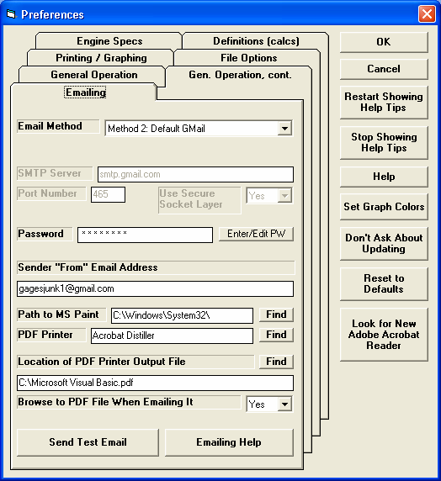
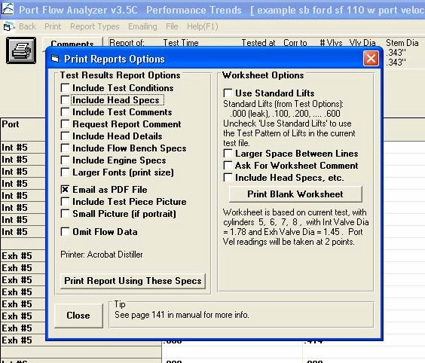
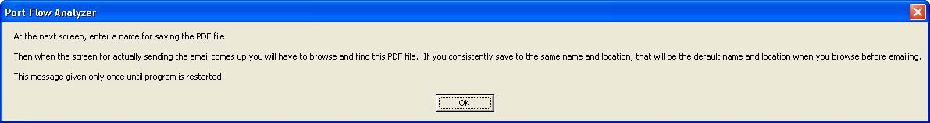
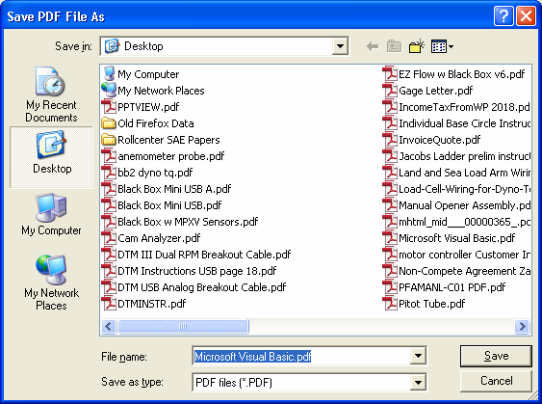
Figure A70 New Emailing Preferences

You can enter a file name and path where the program will write the PDF file for emailing.
Or click the Find button to browse to a PDF file the program has already written.

Check this box to email as a PDF file.
Then click Print Report to create PDF file and get process started for emailing.

Choose the location and file name for writing the PDF file. If you set the Preference of “Browse to PDF File When Emailing It” to Yes, this should be that location and file name.
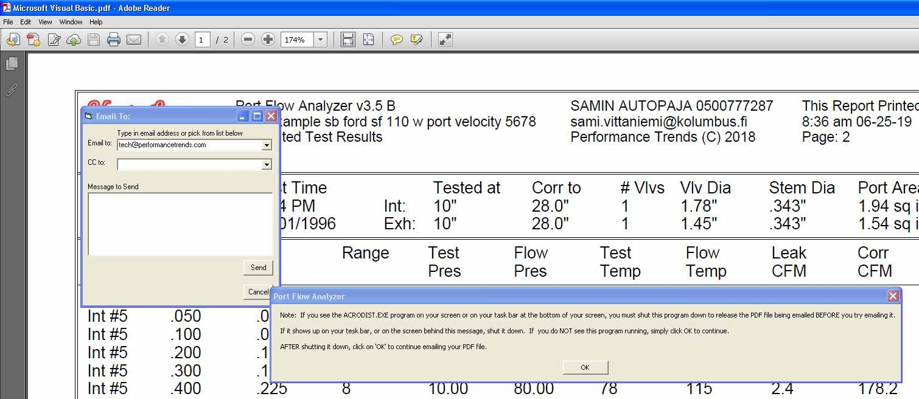
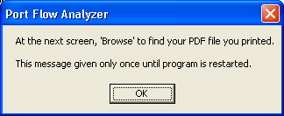
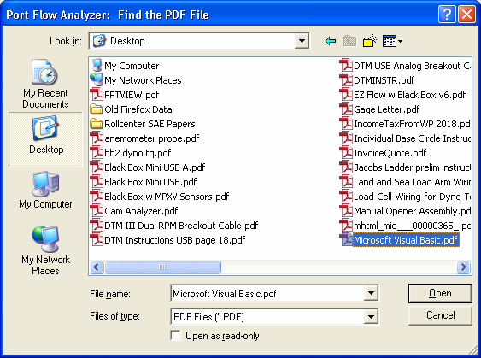
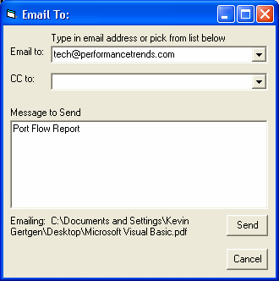
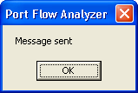
Figure A71 New Emailing Features, cont

Many times Acrobat will open the PDF file to display it, as shown here. As this message describes, if the Port Flow program senses Acrobat has this file open, you MUST shut down Acrobat or Acrobat Reader to release the PDF file for emailing. Once you do this, click OK on this message to continue.

Once Acrobat is shut down, enter “Email to:”, and message, and other info here, then click the Send button.
If you set the Preference of “Browse to PDF File When Emailing It” to Yes, this message will appear. Click OK to proceed to locating the PDF file for emailing.

Browse to the PDF file, then click Open.
Emailing screen after finding and “opening” the PDF file.
Message that email and PDF file have been sent.

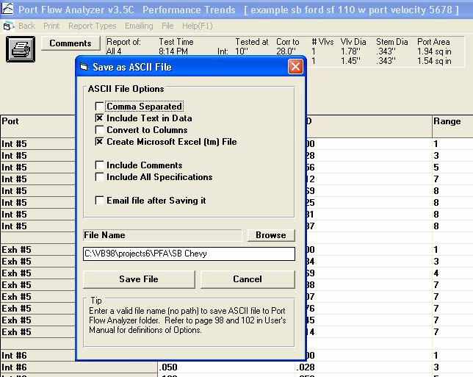
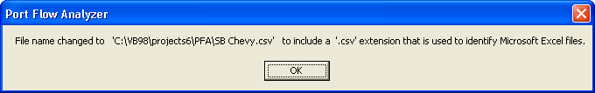
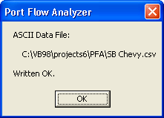
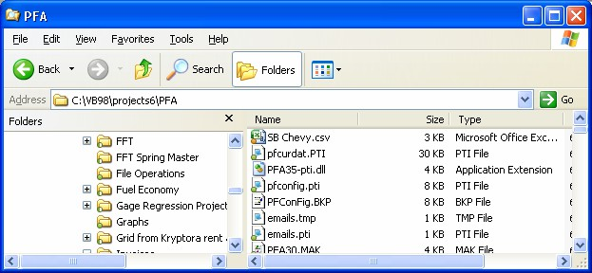
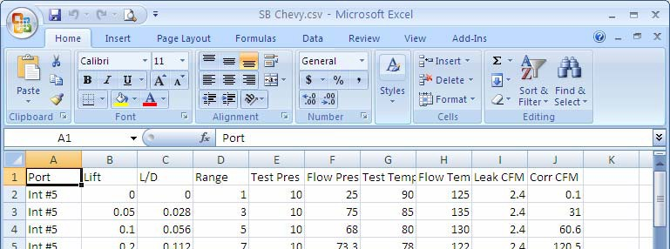
Figure A72 New Export a Report as an Excel File
Click on File at the top of the Report screen to export an ASCII text file of the report.

New option to export as a .csv file which can be open with Microsoft Excel.
New option to automatically email the ASCII file you create.

If the File Name you specify does not end with a .csv extension, one will be added automatically.

File is created and Excel is the default program to open it.

Port Flow Report data opened up in Excel.
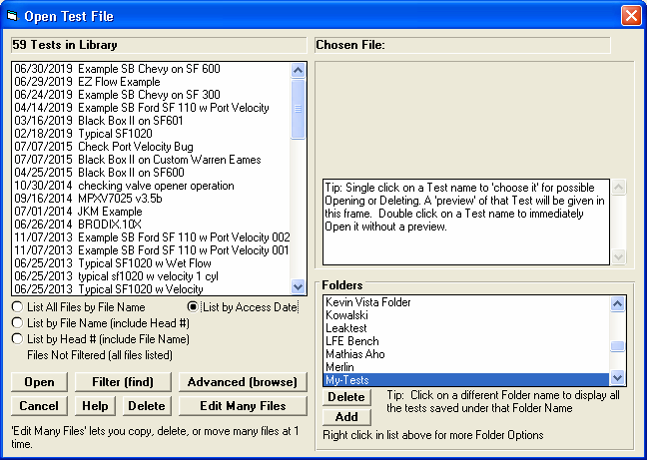
Figure A73 List Files by Access Date

Choose this option and the files will be listed by the date they were last modified or opened.

With this option checked, you will see the date listed here, with the tests with the most recent date listed at the top.

